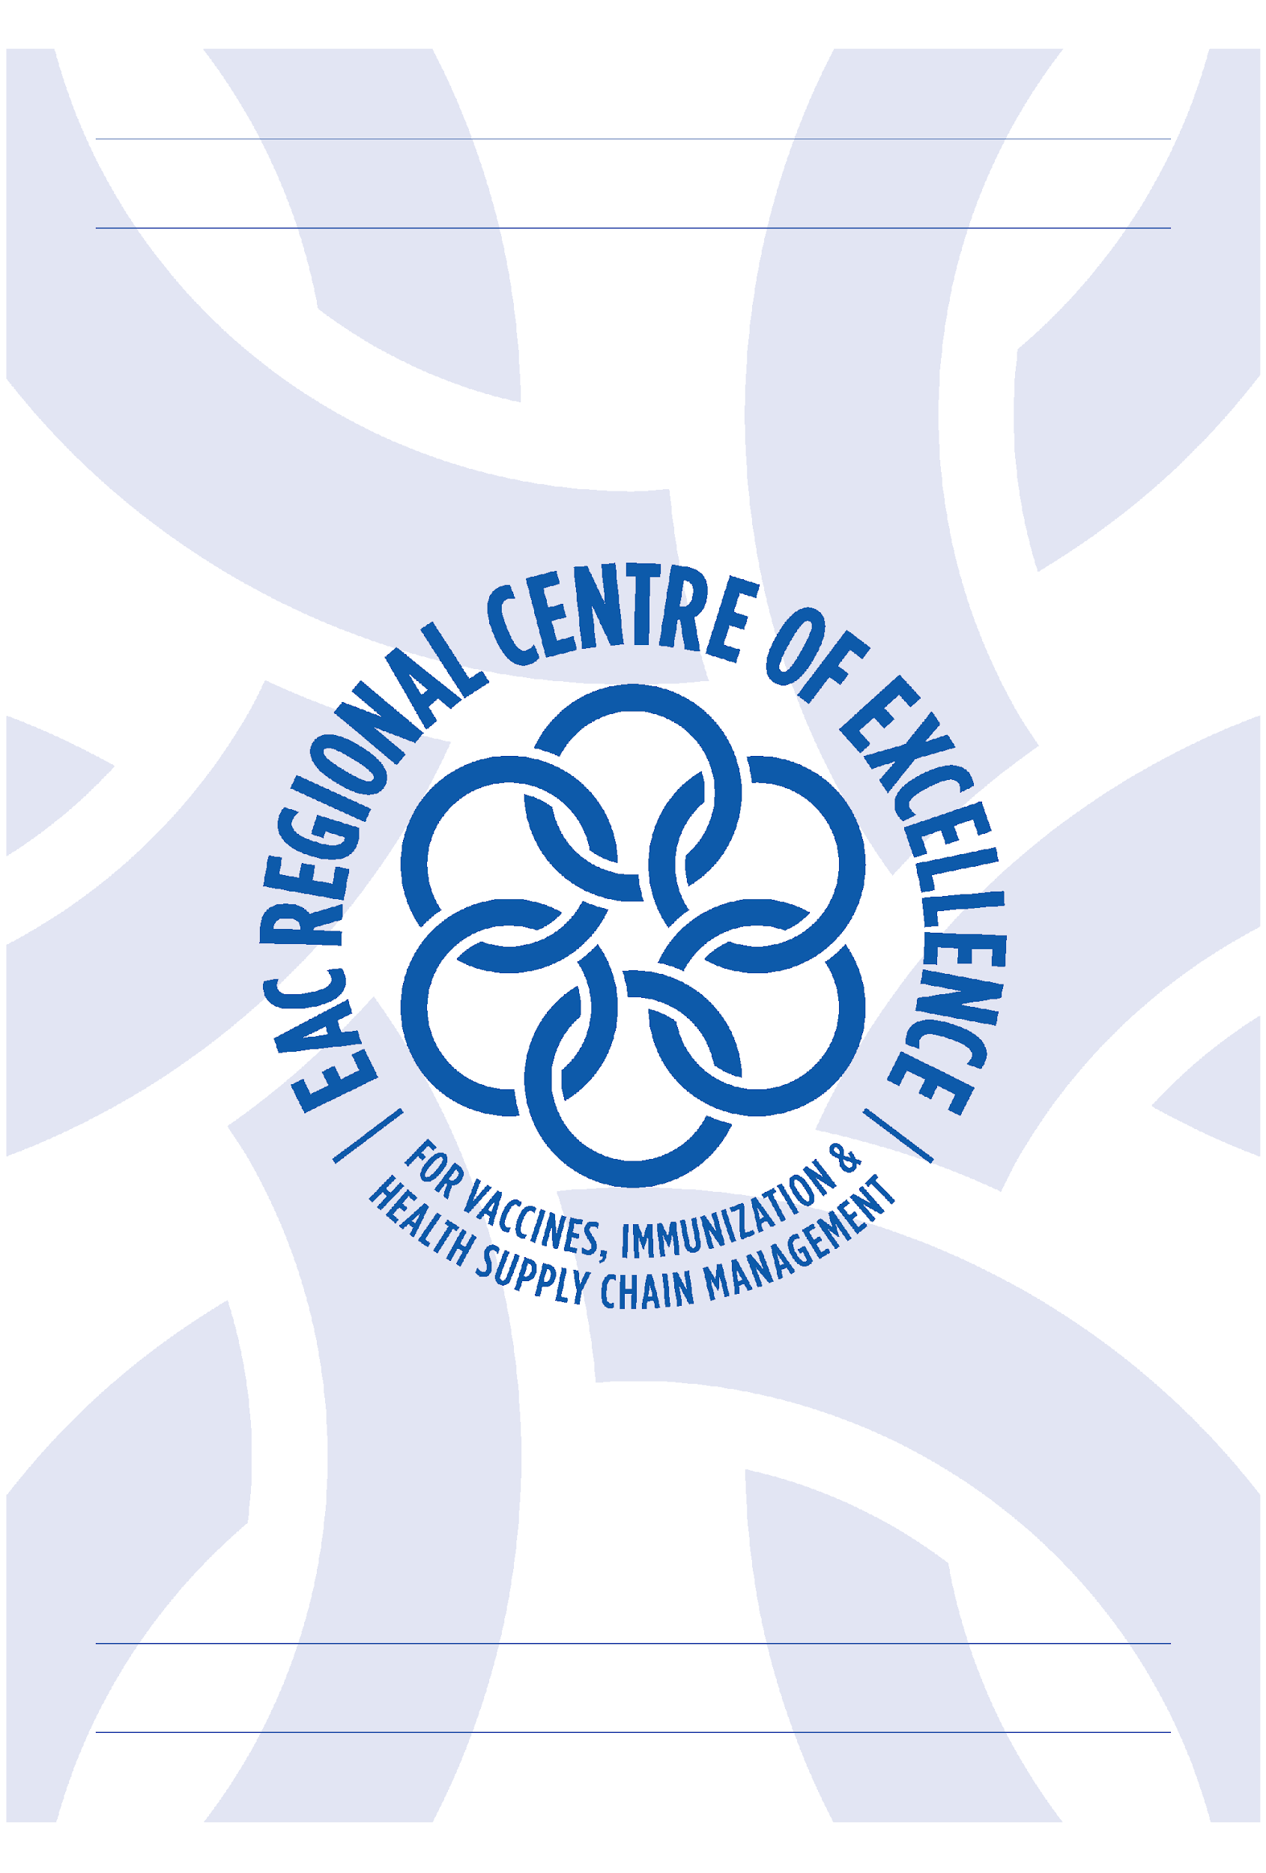

EAC RCE-VIHSCM BI-ANNUAL REPORT
1ST July to 31st December 2025

EAC REGIONAL CENTRE OF EXCELLENCE FOR VACCINES, IMMUNIZATION &
HEALTH SUPPLY CHAIN MANAGEMENT (EAC RCE-VIHSCM)

KG 11 Avenue, Gasabo District • P.O Box 4258, Kigali, Rwanda • info.rcevihscm@ur.ac.rw •

TABLE OF CONTENTS

1. Introduction 5
2. Executive summary 5
3. Summarized achievements in terms of Organizational Development, Governance and Management 7
4. Summarized achievements in terms of training, research and technical assistance 8
5. Main Achievements against plan and deviation from the work plan 14
6. Construction of the RCE-VIHSCM Premises 23
7. Partnership and Collaboration 23
8. Sustainability and RCE as a University of Rwanda affiliated institute 24
9. Financial statement of expenditures for the first semester FY 2025-2026, end on 31st December 2025 25
Annex 1: Update on outcome indicators 28
Annex 2: Master Students per Program 35
Annex 3: The readjusted and approved detailed design for the new site at UR Kicukiro campus 36

PROJECT DESCRIPTION: Ph. II

The project | EAC Regional Centre of Excellence for Vaccines, Immunization, and Health Supply Chain Management
Project’s reference numbers | 2019 67215 and 2015 68 237
Project’s purpose | Supporting the establishment of a regional network organization/knowledge hub aimed at professionalizing and modernizing health supply chain systems in the EAC through capacity strengthening and dissemination of innovation. With additional funding the Centre was tasked to” Create an enabling environment for vaccines manufacturing”.
Project leading principles | - Integrated, multi stakeholders’ approach.  - Coordination and alignment with on-going initiatives at partner states and the EAC level  - Financial sustainability
Project timeline | 2021-2026.
Project recipient | East African Community (EAC)
Project executing agency | University of Rwanda (UR)
Project administrative arrangements | - Financing & Project Agreement and associated Separate Agreement between the EAC, the UR and KFW  - Channeling Agreement between EAC and UR  - Service agreement between UR and GOPA (consultancy firm)

Project budget: Total Cost and Financing, Original & Additional Funding Ph. II

Project Components |  | TOTAL Costs/Budget | Financing
 |  | TOTAL Costs/Budget | FC Contribution Phase II (KfW); Original Funding | FC Contribution Phase II (KfW); Additional Funding for Vaccine Manufacturing | Partner contribution (UR)
Nr. | Project measures | (EUR) | (EUR) | (EUR)
1 | Training Programme Development & Scholarship Fund | 12,560,000 | 6,000,000 | 6,560,000
1a | Of which: Master’s Programmes | 6,500,000 | 2,500,000 | 4,000,000
1b | Of which: Short Courses | 5,010,000 | 3,500,000 | 1,510,000
1c | Of which: Upskilling | 1,050,000 |  | 1,050,000
2 | Research & Sustainability Fund | 2,890,000 | 2,500,000 | 390,000
3 | Equipment & IT Infrastructure Investments | 1,600,000 | 1,300,000 | 300,000
3a | Of which: Minilabs for Quality Control | 400,000 | 400,000
3b | Of which: Cold Chain Skills Lab | 100,000 | 100,000
3c | Of which: IT Infrastructure | 800,000 | 800,000
3d | Of which: Equipment for Training Lab | 300,000 |  | 300,000
4 | Operation, Governance & Regional Integration | 3,625,000 | 1,330,000 | 350,000 | 1,945,000
4a | Of which: Management & Operational Costs | 865,000 | 865,000
4b | Of which: Base salary for RCE staff | 900,000 |  |  | 900,000
4c | Of which: Internet and Moodle Access | 45,000 |  |  | 45,000
4d | Of which: Maintenance of RCE building | 1,000,000 |  |  | 1,000,000
4e | Of which: Governance & Regional Integration | 615,000 | 265,000 | 350,000
4f | Of which: EAC Monitoring/Evaluation | 200,000 | 200,000
5 | EAC Pooled Procurement Mechanism | 900,000 |  | 900,000
6 | FC Consultancy Services & Audit | 1,570,000 | 1,070,000 | 500,000
7 | Contingencies | 2,800,000 | 1,800,000 | 1,000,000
 | Total financing requirement | 25,945,000 | 14,000,000 | 10,000,000 | 1,945,000
 | Financed through | (EUR) | (EUR) | (EUR)
 | FC (KfW grant on behalf of BMZ) | 24.000.000 | 14,000,000 | 10,000,000
 | Own contribution executing agency | 1,945,000 |  |  | 1,945,000
 | Total financing | 25,945,000

Introduction
This Bi-Annual Report covers the first semester of the 2025/2026 fiscal year (1 July–31 December 2025). It presents the activities carried out by the EAC Regional Centre of Excellence for Vaccines, Immunization, and Health Supply Chain Management (EAC RCE-VIHSCM). These activities were primarily financed under Phase II of the Financing and Project Agreement No. 2019 67 215, signed between the East African Community (EAC), the University of Rwanda (UR), and the German Development Bank (KfW).

During the reporting period, activities were funded through the Phase II Disposition Fund and the Phase I construction component (Financing and Project Agreement No. 2015 68 237). The initial Phase I construction budget of EUR 4,583,114 proved insufficient, necessitating the reallocation of EUR 2,300,000 from the Phase II contingency budget. This adjustment increases the total construction budget to EUR 6,883,114. The reallocation was jointly agreed upon by UR- EAC RCE-VIHSCM and KfW.

The Bi-Annual Report also presents a retrospective analysis of key activities carried out during the reporting period and assesses their outcomes. It also highlights the implementation challenges encountered and the mitigation measures adopted.

Executive summary
During the reporting period, the EAC RCE-VIHSCM made significant progress in the implementation of the planned activities. The approved budget for the Fiscal Year 2025–2026 amounted to EUR 6,127,407, of which EUR 4,396,349 was funded by KfW, EUR 1,188,320 by the African Development Bank (AfDB), and EUR 542,738 from internally generated revenues. Out of the total KfW-approved budget, EUR 1,888,538.50 was spent in the first semester (July–December 2025), representing 42.9% of the allocation.

For internally generated funds, which primarily cover operational costs, expenditure during the reporting period amounted to EUR 412,376 out of the EUR 542,738 representing 76% of the approved internal generated revenue budget, mainly due to the UR/SPIU initiative to transfer all projects salaries and allowances to the SPIU account for the whole year to smoothen the timely payment of salaries and operations costs.
During the same period, expenditure under the AfDB budget amounted to EUR 215,959, representing 18% of the approved AfDB allocation. The relatively low level of budget absorption was mainly due to delays in the recruitment of key staff required to implement the planned activities. To date, one staff member has been recruited, and this provides an opportunity to fast track the activities and thus accelerate expenditure during the remaining implementation period.
During the reporting period, several key activities were successfully implemented, reflecting the progress made in academic and professional training. A major achievement was the enrollment of students in the two newly developed programs: the MSc in Vaccinology (MVAX) enrolled 42 students and the MSc in Medical Products Regulatory Affairs (MPRA) enrolled 35 students.
On the other hand, 43 students and 28 students were enrolled in the Master’s in Health Supply Chain Management (MHSCM) and MSc in Pharmaceutical Analysis and Quality Assurance (MPAQA) respectively. Importantly, the masters’ programs have admitted 24 private students, which is an achievement that needs additional efforts in creating awareness about the existing programs.
On 17th October 2025, 38 candidates from the 5th intake of the Master’s in Health Supply Chain Management program graduated at Huye Campus making a total of 173 graduates since the start of the programme. Ongoing students in both the MPAQA and MHSCM programs have continued their studies. Short courses were also organized during the reporting period. Five short course trainings were organised and attended by 74 trainees. Furthermore, the revised Master’s Program in Health Supply Chain Management was approved at the College level, and forwarded to the University Senate level for further approval before it is sent to HEC for final approval.
Besides, students from MPAQA intake one and MHSCM intake 6 have completed industrial attachment. In addition, nine PhD students out of ten who were given scholarships have started their studies.
The EAC RCE-VIHSCM recruited a consultant to develop the EAC Health Supply Chain Professionalization Strategy as a key step toward supporting the recognition of the health supply chain management profession within national human resource development plans. As the initial phase of this process, a Situational Analysis Study is nearing completion, with its validation scheduled for January 2026. Subsequently, the development of the Strategy will promptly start, guided by the findings of the Situation Analysis Report.
During the reporting period, 35 applications were received in response to the 4th Call for Research Proposals, of which 11 were competitively selected for funding. The selection process has now been successfully completed and award letters have been issued.
During the reporting period, significant progress was made under the construction component, including the evaluation of tender bids and the submission of the bid evaluation report to the funder, KfW, for No Objection (NO). However, some delays are anticipated, as of 20th December 2025, the funder requested more clarification as feedback on the submitted bid evaluation report, which is currently under review. This is expected to result in further delays in the process.
The progress achieved during the first semester (July–December 2025) underscores the strong commitment of both the funder and the University of Rwanda – RCE-VIHSCM to establishing the Centre’s premises at the earliest possible time. The report additionally presents an updated status of the outcome indicators, as outlined in Annex 1.

Summarized achievements in terms of Organizational Development, Governance and Management
The EAC RCE-VIHSCM secured a grant from the Deutsche Gesellschaft für Internationale Zusammenarbeit (GIZ) to support the initiative on Strengthening Regulatory Harmonization and Pooled Procurement for Increased Availability of Medical Commodities in the EAC Region. Negotiations commenced during the reporting period, with both parties expect to finalize the activities and corresponding budgets in due course. The support will be through two approaches, by direct funding of Euros 300,000 to support regional coordination (2026-2027) and indirect funding through GOPA World Wide consulting Group (2025-2028).
The Annual Work Plan and Budget for FY 2025–2026 was developed and submitted to the National Steering Committee for review and approval, in line with the established guidance on RCE performance.
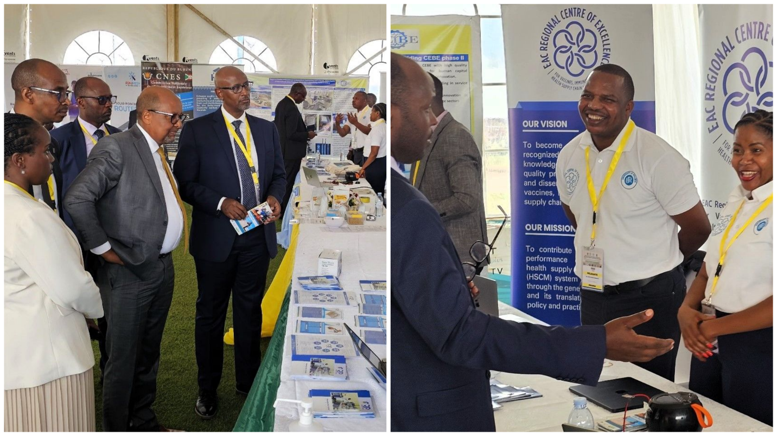
As part of regional integration, the EAC RCE-VIHSCM participated in the exhibition held alongside the 1st Regional Ministerial Conference on the East African Common Higher Education Area (EACHEA).
Hon. Joseph Nsengimana, Rwanda Minister of Education (5th left), with senior education officials, visit the EAC RCE-VIHSCM stand at the EAC Common Higher Education Area (EACHEAC) exhibition in Kampala, Uganda (9–11 September 2025)
From 18th to 22nd August 2025, a team from the Kenya Medical Training College conducted a study visit to Rwanda. During this visit, the EAC RCE-VIHSCM was engaged in discussions on potential academic and research collaborations, including joint curriculum development, staff and student exchanges, and research partnerships.
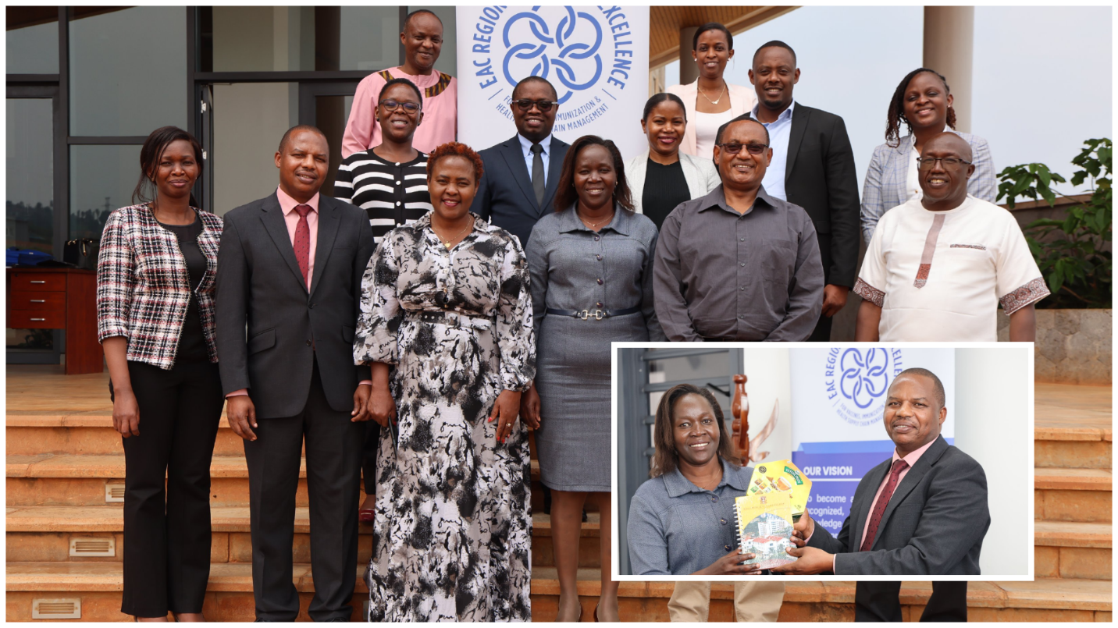
Kenya Medical Training College (KMTC) delegation received at EAC RCE-VIHSCM on 21st August 2025 during their benchmarking study visit to the University of Rwanda EAC Centers of Excellence: Inset: Ms. Lucy Chebungei of KMTC and Mr. John Patrick Mwesigye of EAC RCE exchange mementos
During the reporting period, a consultant was engaged to conduct the Mid-Term Review of the EAC RCE-VIHSCM Strategic Plan (2020–2029). At the time of reporting, the inception report had been approved, data collection was ongoing, and data analysis is scheduled to commence in the first quarter of 2026.
In addition, an external auditing firm was contracted to carry out the audit for the 2024–2025 financial year. The audit was completed successfully, and the EAC RCE-VIHSCM received an unqualified (clean) audit opinion.
The RCE produced and published a quarterly newsletter during the reporting period. To access the newsletter, please click the following link: EAC RCE-VIHSCM Quarterly Newsletter - Issue No.17

Summarized achievements in terms of training, research and technical assistance
- A call for applications for the 2025–2026 academic year was launched, attracting 2,200 applicants. The selection of eligible candidates had been completed in the reporting period.
- The EAC RCE-VIHSCM has enrolled 148 new students in four master’s programs, including the two newly developed programs (MSc in Vaccinology and MSc in Regulatory Affairs) in the academic year 2025–2026. These students include 124 scholarships and 24 self-sponsored students. The induction program for newly enrolled students was conducted from 24th to 29th November 2025.

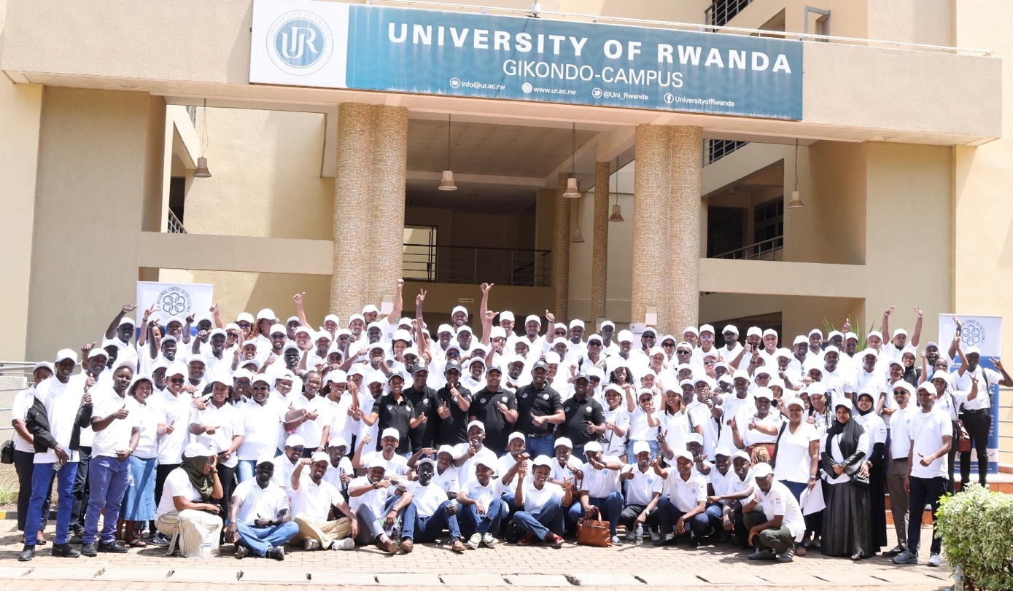
Group photo of new Master’s program students from all EAC Partner States (in white) together with RCE staff (in black) during the induction week, held from 24–29 November 2025 at the University of Rwanda, Gikondo Campus
The graduation ceremony for the 5th cohort of the Master of Health Supply Chain Management program was held on 17th October 2025, during which 38 students successfully graduated. Although the indicator suggests a large number of graduates this academic year, MPAQA program did not graduate, and the two newly introduced programmes experienced delays in approval, which postponed their start and subsequently affected graduation numbers.

Proud graduates of the 5th cohort of the Master’s in Health Supply Chain Management (MHSCM) at the 11th University of Rwanda graduation ceremony (17th October 2025, at Huye Campus)
- The development of teaching materials for the reviewed Master of Health Supply Chain Management was done during the week of July 28th to August 01st 2025.
- The orientation of academic staff who are facilitating the first-year modules of the MSc in Vaccinology and MSc in Medical Products Regulatory Affairs was organized from 21st to 25th July 2025.
- From 1st to 5th September 2025, a training program for Laboratory Technicians in Biomanufacturing Practices was organized to support the effective delivery of laboratory-based modules. The training targeted technicians who will facilitate lab-based modules in the MPAQA and MVAX programs.
- Twenty-six (26) Master’s students from the first intake of the MSc in Pharmaceutical Analysis and Quality Assurance (MPAQA) completed two months’ industrial attachment. The industrial attachments were conducted in pharmaceutical and vaccines manufacturing industries and National Regulatory Agencies located in the EAC Partner States.
- End of semester two exams for MHSCM intake 7 were organized from 27th to 31st October 2025
- Semester three face to face classes for MHSCM Intake 7 were conducted from 1st to 14th November 2025.
- Semester two laboratory practicals for MPAQA intake 2 were organized from 24th to 28th November 2025.
- End of semester two exams for MPAQA intake 2 were organized from 01st to 05th December 2025.
- Semester three face to face classes for MPAQA intake 2 were conducted from 8th to 12th December 2025.
- Semester one face-to-face classes for MHSCM Intake 8 and MRA Intake 1 were conducted from 01st to 12th December 2025.
- Semester one face-to-face classes for MVAX Intake 1 and MPAQA Intake 3 were conducted from 01st to 19th December 2025.
- Between July and December 2025, the RCE continued to enhance the capacity of healthcare professionals across EAC Partner States by delivering short-term professional courses. During these six months, the RCE trained 74 healthcare professionals. It is important to note that in this period, out of 74 trainees, 30 are females, representing 40.5% of the total number of trainees. From this number, the total (cumulative) number of trainees since the establishment has reached 2,978.
The table below provides details of trainings offered, the number of trainees by country and by gender between July to December 2025.

Table 1: Type of short courses by country and gender July to December 2025

No | Course Name/Type | Burundi |  | Kenya |  | Rwanda |  | South Sudan |  | URT |  | Uganda |  | Fed. Rep. Somalia |  | DRC |  | Total trainees
No | Course Name/Type | M | F | M | F | M | F | M | F | M | F | M | F | M | F | M | F | M&F
1 | Supply Chain System Design/Optimization and Use of SCANIT Tool | 0 | 0 | 1 | 0 | 0 | 4 | 2 | 0 | 2 | 1 | 1 | 1 | 2 | 0 | 0 | 0 | 14
2 | Good Standards Practices (GxP) | 2 | 0 | 1 | 1 | 2 | 0 | 0 | 2 | 0 | 2 | 1 | 1 | 0 | 0 | 0 | 0 | 12
3 | GMP for Vaccines and Other Medical Products | 0 | 0 | 2 | 2 | 7 | 2 | 0 | 1 | 2 | 2 | 0 | 3 | 1 | 1 | 0 | 0 | 23
4 | Biomanufacturing ToT for MPAQA & MVAX facilitators | 0 | 0 | 0 | 0 | 3 | 2 | 0 | 0 | 0 | 0 | 0 | 0 | 0 | 0 | 0 | 0 | 5
5 | International Vaccinology Course | 0 | 1 | 0 | 0 | 5 | 1 | 1 | 1 | 3 | 1 | 2 | 1 | 2 | 0 | 2 | 0 | 20
 | Trainees by Gender & Country | 2 | 1 | 4 | 3 | 17 | 9 | 3 | 4 | 7 | 6 | 4 | 6 | 5 | 1 | 2 | 0 | 74
 | Total number of males trained for the 5 training courses |  |  |  |  |  |  |  |  |  |  |  |  |  |  |  |  | 44
 | Total number of females trained for the 5 training courses |  |  |  |  |  |  |  |  |  |  |  |  |  |  |  |  | 30
 | Total number of Trainees for the reporting period (July - Dec 2025) |  |  |  |  |  |  |  |  |  |  |  |  |  |  |  |  | 74

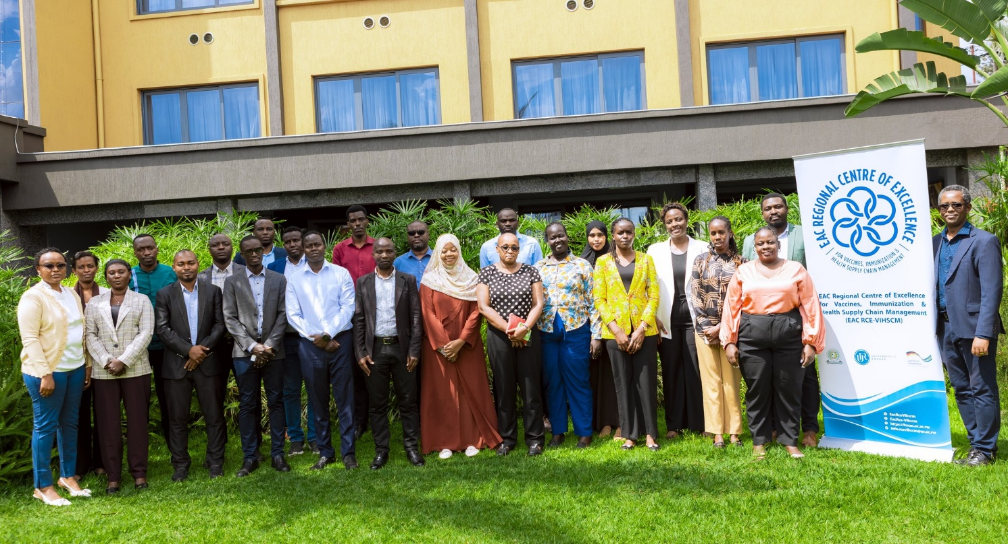
Participants at the Good Manufacturing Practices (GMP) for Vaccines & Medical Products training, held in Kigali from 15–19 December 2025.

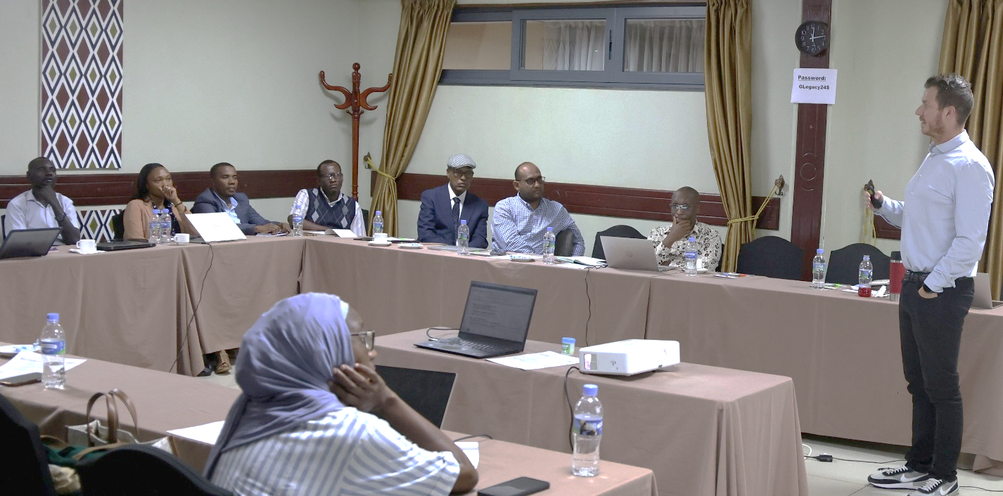
Participants at the EAC RCE & UNICEF Supply Division SCANIT Train-the-Trainers workshop

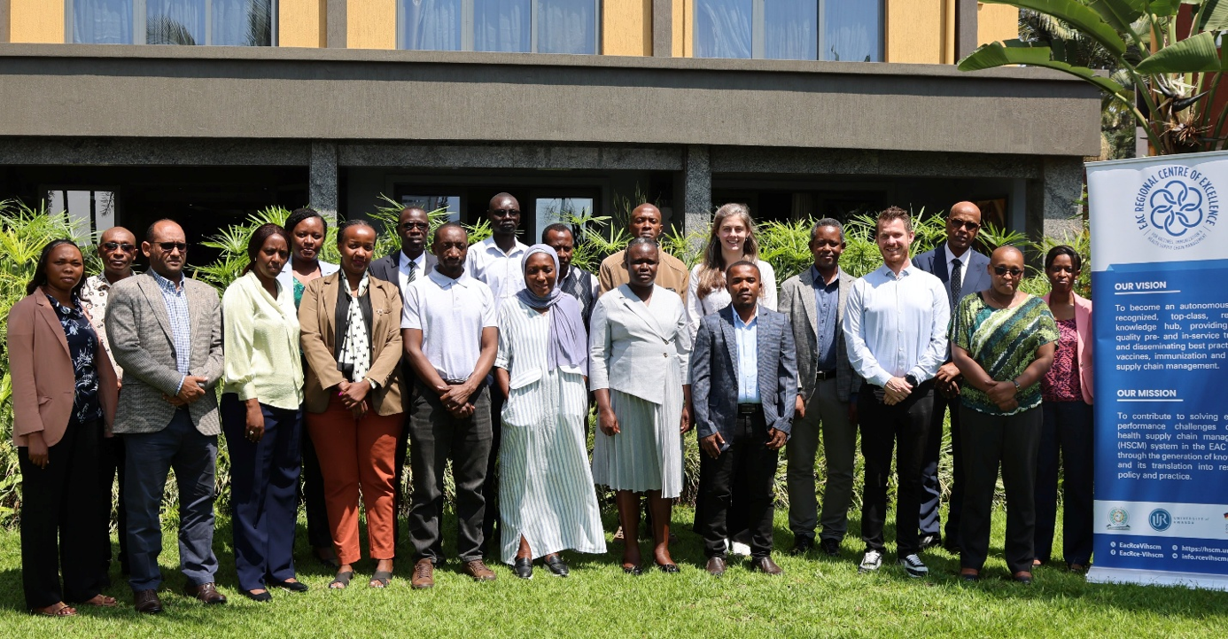
RCE-trained trainers on Supply Chain Design and Optimization using the innovative Supply Chain Analysis & Intelligence Tool (SCANIT) pose for a group photo during the training held in Kigali from 12–14 November 2025

Under the Research and Technical Assistance component, the following activities were undertaken:
During the reporting period, 35 applications were submitted for the 4th Call for Research Proposals. After a thorough and competitive review process, 11 proposals were approved for funding. The selection process has been finalized, and award letters were issued. Awardees are currently finalizing their activity plans and budgets to sign the research agreement and begin project implementation.
During the reporting period, the Centre continued to oversee and monitor the implementation of the seven research projects funded under the 3rd cohort, ensuring alignment with approved work plans and grant requirements.
Following an extended recruitment process, under AfDB support, the Centre successfully appointed a Senior Pooled Procurement Officer, who will officially join the Centre in January 2026. He will provide strategic and operational oversight of activities under the EAC Pooled Procurement Mechanism, thereby spearheading the operationalization of the EAC Pooled Procurement Mechanism.
A five-day meeting was conducted from 25th to 29th August 2025 in Entebbe, Republic of Uganda, to review reported data, identify gaps and challenges in reporting, prepare a report to be shared with the stakeholders for coordinated informed buying, and enhance the digital platform where needed based on the identified gaps.
During the period, a consultant was hired to develop the Professionalization Strategy for the EAC Health Supply Chain Workforce in the EAC Partner States. A situational analysis study is currently in progress, and a review and validation meeting for the Situation Analysis Report is scheduled for January 2026. After the report is finalized, it will inform the development of the Health Supply Professionalization Strategy, which will commence immediately. In this reporting period, the Centre published ten articles.
A joint proposal-writing workshop was organized in partnership with the EAC Secretariat to prepare an application for the 3rd call for the Pandemic Fund. Although our proposal was duly prepared and timely submitted, it was not successful.
Follow-up of PhD students awarded scholarships continued. Nine out of ten are progressing well in their studies, while one student, due to administrative reasons, was relocated from Muhimbili University of Health and Allied Sciences (MUHAS) to the University of Rwanda. Here below is their summary progress.

Table 2: Students selected for the PhD program
Student name | Country | Host University | Area of Research | Status
Gilbert Rukundo | Rwanda | Birmingham University/ UK | Vaccine Cold Chain | Started Sept 2024
Herve Semukunzi | Rwanda | Birmingham University/ UK | Immuno Diagnostic | Started Sept 2024
Macro N. Masala | URT | University of Twente/Netherlands | HSCM/Pooled Procurement | Started Sept 2024
Diana Nakitto Kesi | Uganda | University Medical Center Groningen/ Netherlands | Regulatory Affairs | Started Oct 2024
Pierre Celestin Munezero | Rwanda | University of Guelph/Canada | Vaccinology | Started September 2025
Moses Orwe | Kenya | University of Guelph/Canada | Vaccinology | Started September 2025
Lazare Ntirenganya | Rwanda | Karolinska Institutet/ Sweden | QA/QC | Started September 2025
Silas Georges Shemdoe | URT | MUHAS | QA/QC | Started May 2024
Theogene Ihorimbere | Burundi | Addis Ababa University | HSCM/ AMR & One Health | Started November 2025
Lambert Christophe Safari | Rwanda | University of Rwanda | QA/QC | To get the new Nomination letter

Main Achievements against plan and deviation from the work plan
The table below presents a summary of the key accomplishments of the EAC Regional Centre of Excellence for Vaccines, Immunization, and Health Supply Chain Management (EAC RCE-VIHSCM) during the reporting period of July to December 2025. These achievements are measured against the planned activities outlined in the Annual Workplan and Budget (AWP/B) for the 2025–2026 Fiscal Year. Where applicable, the table also highlights implementation challenges and corresponding mitigation strategies.

 | Function | Planned activities July to December 2025 | Main achievements under activity area July to December 2025 | Deviation from the work plan
1 | Governance and Management | To prepare the revision of the RCE –VIHSCM Annual Work Plan and Budget prepared, 2025-2026.  Prepare the EAC RCE-VIHSCM Annual Procurement Plan based on the revised AWP/B 2025-2026 and share it with the UR Single Project Implementation Unit (SPIU) for compilation and submission to UR.  Organize an NSC to approve the RCE AWP/B for the FY 2025-2026  To launch a tender (framework contract) for an external audit of the disposition fund.  To launch a tender to hire a consultant to review the RCE Strategic Plan 2020-2029  Organize and participate in the 26th Ordinary Meeting of the EAC Sectoral Council of Ministers of Health  To organize and participate in at least one of the Regional Steering Committee (RSC) meetings.  To organize and participate in the M&E meeting for all EAC CoEs.  To continue to follow up on the institutional and organizational development of the EAC RCE-VIHSCM as an affiliated institute of UR.  To continue to follow up on partnership and signing of MoUs with stakeholders | - The Annual Work Plan and Budget FY 2025-2026 were revised, prepared and ready to be approved by the NSC early January 2026  - The Procurement Plan was prepared and submitted to SPIU as planned.  - The 14th NSC was held and approved the revised AWP/B FY 2025-2026  - The tender was conducted and the RCE got a clean report  - The consultant was hired to review the RCE strategic plan and the assignment is ongoing. The inception report was approved, data collected now being analysed.  - Not yet scheduled at the EAC Secretariat level/pending  - Not yet scheduled at the EAC Secretariat level/ pending  - The RCE was represented in the M&E meeting for CoEs that took place in Nairobi. The representative presented the RCE progress as well and shared experiences with other representatives of CoEs.  - A high-level summary roadmap of the RCE as an affiliated institute was developed and shared with stakeholders including the funder (KfW).  - In this reporting period, a tripartite MoU was signed between the University of Rwanda, Kairuki Pharmaceutical industry and Kairuki University. | The meeting has not taken place  The meeting has not taken place. However, it will take place in February 2026
2 | Training: Master’s programs | To graduate the fifth intake of the master’s program in HSCM.  To continue teaching ongoing classes from intakes 6 & 7 of the master’s program in HSCM.  To continue teaching ongoing classes from intakes 1 &2 of the MSc in MPAQA.  To enroll the eighth intake of 40 students for the master’s program in HSCM.  To enroll the third intake of 30 students for the master’s program in Pharmaceutical Analysis and Quality Assurance (MPAQA).  Official launch of the New Masters’ programmes  To enroll the inaugural cohort of 30 students for the MSc in Vaccinology  To enroll the inaugural cohort of 30 students for the MSc in Regulatory Affairs Medical Products  To orient academic/teaching staff for the MSc in Vaccinology and MSc in Medical Products Regulatory Affairs  To develop the teaching materials for the reviewed MHSCM  To pilot remote study site (s) for training programs | - The University of Rwanda graduation ceremony was organized and 38 students of the 5th intake have graduated.  - Ongoing students from intakes 6&7 have continued studying. They did exams for the last semester and introduced face to face courses for this semester.  - Ongoing students from intakes 1&2 of the MSc in MPAQA have continued studying. MPAQA 2 did lab practical and exams of the semester two and introduced face to face classes for semester three. MPAQA 1 did their industrial attachment.  - The eighth intake of the Health Supply Chain Management (HSCM) programme was enrolled, comprising 43 students, of whom three (3) are privately sponsored.  - The third intake of the Master of Science in Pharmaceutical Analysis and Quality Assurance (MPAQA) programme was enrolled, with a total of 28 students, all of whom were fully sponsored (no privately funded students).  - This activity was not implemented during the reporting period due to the unavailability of key stakeholders and was therefore postponed to a later date.  - The first cohort of the Master of Science in Vaccinology programme was enrolled, comprising 42 students, of whom 14 were privately sponsored.  - The first cohort of the Master of Science in Regulatory Affairs Medical Products programme was enrolled, with a total of 35 students, of whom 7 were privately sponsored.  - Academic staff assigned to teach year one modules of the newly developed programmes were provided with an orientation course, which equipped them with the skills required to deliver instruction, including through online teaching platform  - The teaching materials for the reviewed MHSCM were developed as planned  - The pilot remote study site visit(s) did not take place during the reporting period and were therefore rescheduled for implementation in the second semester.
3 | Training: Short Courses and Upskilling | Development of the Humanitarian Supply Chain Management  Train The Trainers:  STEP 2.0 Leadership Course in Supply Chain System Design, Supply Chain System Design (Tool) with UNICEF SD, Forecasting and Supply Planning (Tool) with UNICEF SD, Vaccinology: February and Lab Technicians on Biomanufacturing Practicals  To organize short courses mix:  Immunisation Supply Chain (iSC) online  Global Standards for Traceability of Health Products and Technologies (GSTHPTs)  Cold Chain Equipment Management (CCEM) - Phase 1 online  Cold Chain Equipment Management (CCEM) - Phase 2  Good Manufacturing Practices (GMP)  Quality Control (QC)  c. Upskilling (3) by AfDB funds  Standards Practices by IVI  Biologics Development and Manufacturing by IVI  Bioanalytical Techniques by EDA/FDA Ghana | - This course is not yet developed but will be developed in the first quarter of the year 2026.  - Of the five (5) planned Training of Trainers (ToTs), two (2) were conducted during the reporting period, while the remaining three (3) are scheduled to be organized in the second semester of the 2025–2026 fiscal year. The two ToTs conducted focused on Supply Chain System Design (Tool) in collaboration with UNICEF Supply Division, and Biomanufacturing Practicals for Laboratory Technicians.  - The Immunisation Supply Chain (iSC) course is ongoing since it started online as planned on 12th December 2025  - The GSTHPTs course is still ongoing since it started online as well on 12th December 2025  - The CCEM course is ongoing it has started online from 12th December 2015  - The CCEM course Phase 2 will start in the second semester once Phase 1 of it is complete.  - The GMP course was successfully organized from 15th to 19th December 2025  - The QC course is planned in the first quarter of the second semester 2026  - This course was successfully organized, held in south Korea and 12 staff from EAC Partner States were supported participate in the training  - This course will be organized in the second semester of the fiscal year 2025-2026  - This course is planned to be organized in the second semester of the fiscal year 2025-2026
4 | Research | To continue regularly update the EAC RCE-VIHSCM digital repository (resource centre) of research outputs and datasets on VIHSCM in the EAC region and beyond.  To award the 4th and 5th rounds of small research grants and continue monitoring the ongoing small research grants (3rd round).  To conduct a manuscript writing workshop for the 6th Intake MHSCM and 1st MPQA to increase the number of publications  To apply for 1 grant in the EAC RCE-VIHSCM priority areas.  Operationalize and implement RCCN Activities  To implement activities of the EAC Pooled Procurement Mechanism. Delayed due to the delay of the recruitment of the staff  To develop the EAC health supply chain professionalization framework in collaboration with People that Deliver (PtD).  To follow up on the PhD scholarship program  To host at least one scientific conference  Organize one EPI managers meeting in collaboration with development partners | - The VIHSCM digital repository is regularly updated  - 35 applications were received in response to the 4th Call for Research Proposals, of which 11 were competitively selected for funding. The selection process has now been successfully completed and award letters have been issued.  - The manuscript workshop is normally conducted towards the end of the second semester once students have defended their theses.  - The RCE team, in collaboration with the EAC Secretariat, submitted a grant application; however, the application was not successful.  - This activity did not take place during the reporting period due to the resignation of the person leading the ABI assignment, which caused a delay in its implementation. However, the Conference of the Parties is scheduled in February 2026.  - Following an extended recruitment process, the Centre successfully appointed a Senior Pooled Procurement Officer, who will officially join the Centre in January 2026. He will provide strategic and operational oversight of activities under the EAC Pooled Procurement Mechanism, thereby spearheading the operationalization of the EAC Pooled Procurement Mechanism.  - A five-day meeting was conducted from 25th to 29th August 2025 in Entebbe, Republic of Uganda, to review reported data, identify gaps and challenges in reporting, prepare a report to be shared with the stakeholders for coordinated informed buying, and enhance the digital platform where needed.  - A consultant was hired to develop the Professionalization Strategy for the EAC Health Supply Chain Workforce in the EAC Partner States. A situational analysis study is currently in progress, and a review and validation meeting for the Situation Analysis Report is in January 2026. After the report is finalized, it will inform the development of the Professionalization strategy, which will commence immediately.  - PhD students are progressing well except one who was relocated to the University of Rwanda from MUHAS in the United Republic of Tanzania.  - The scientific conference was not hosted due to the reallocation of funds to the RCCN Conference of the Parties, scheduled for February 2026.  - This event did not take place. During the budget revision, it was agreed to remove it from the plan and postpone it to the next fiscal year 2026-2027 because many EPI are into reforms and it is not a good timing for the managers meeting.

Construction of the RCE-VIHSCM Premises
During the reporting period, significant progress was made under the construction component, including the review and adjustment of tender documents and their resubmission for No Objection (NO). However, delays were encountered, including a two-month delay from the consultant, prompting a request for a catch-up plan, and additional delays arising from the iterative process of addressing comments and securing the NO from KfW. The No Objection to issue the Invitation for Bids was eventually received, prequalified bidders were invited, and the site visit was successfully conducted. During the bid opening, two bidders submitted their proposals while one was unable to participate.

The evaluation of bids was conducted, and a report was submitted to the funder for No Objection but more clarification was requested. The challenge is that it will require more work on the evaluation process and thus creating more delays on the construction component.

In summary, key challenges included repeated document revisions, consultant delays, logistical issues affecting bid participation, and lengthy No Objection cycles. Planned next steps include obtaining the No Objection for the evaluation report, notifying the successful bidder, awarding the contract, and initiating preparatory construction works through continued coordination with KfW, CBM, and the consultant.


The readjusted and approved detailed design for the new site at UR Kicukiro campus

Partnership and Collaboration
During the reporting period, the RCE maintained active engagement with stakeholders across the EAC Partner States. While several Memoranda of Understanding (MoUs) were initiated, one tripartite MoU was successfully signed between the University of Rwanda/EAC RCE-VIHSCM and Kairuki Pharmaceutical Industries and Kairuki University in the United Republic of Tanzania (URT). Follow-up efforts are ongoing to finalize and formalize the remaining MoUs.
The EAC RCE-VIHSCM continued to strengthen strategic partnerships, which enabled the successful implementation of various activities with the support of key stakeholders. These collaborations facilitated the admission and supervision of PhD students, delivery of master’s programmes, organization of short courses, and promotion of research and professional upskilling. In addition, partner institutions hosted RCE students for industrial attachments.
Furthermore, the RCE secured additional funding from GIZ, primarily to support EAC pooled procurement activities, thereby strengthening regional collaboration and operational capacity in this area.

Sustainability and RCE as a University of Rwanda affiliated institute
The EAC RCE-VIHSCM has made significant investments to ensure its long-term sustainability. One of the key drivers of this sustainability is the substantial investment in high-quality academic programmes, including both Master’s programmes and short-term professional courses developed by the Centre. These programmes are expected to attract private students whose tuition fees will contribute to sustaining the Centre’s operations. In addition, the EAC Partner States have expressed their willingness to support the Centre’s sustainability. However, what is still required is the establishment of a clear framework to guide and operationalize these contributions.
The Centre serves as a co-host and training hub for the Eastern Africa Regional Capability and Capacity Network (RCCN). This initiative forms part of a broader continental strategy spearheaded by the Africa Centres for Disease Control and Prevention to strengthen Africa’s health workforce capabilities and expand local manufacturing capacity across the continent. Through its role in the RCCN, the Centre contributes to building a skilled workforce that can support the development of regional pharmaceutical and vaccine manufacturing ecosystems. This strategic positioning further enhances the Centre’s visibility, partnerships, and resource mobilization opportunities, thereby contributing significantly to its long-term sustainability.
Building on these strategic initiatives, additional measures are being implemented to further strengthen the Centre’s long-term sustainability. Through the support of the KfW Development Bank grant, the Centre is funding a number of PhD students who are expected to later serve as faculty members. This approach will gradually build an internal pool of highly qualified academic staff, thereby reducing reliance on external faculty and ensuring continuity in teaching, research, and capacity-building activities.
Furthermore, the completion of the RCE building will provide the Centre with a permanent institutional home. This dedicated infrastructure will enhance the Centre’s operational capacity, strengthen its institutional identity, and provide a stable base for delivering training, research, and regional collaboration activities in the long term.
In addition, the Centre is strategically positioned within a rapidly evolving regional health and pharmaceutical ecosystem. With the full operationalization of key continental and regional initiatives such as the African Medicines Agency (AMA), the African Pharmaceutical Technology Foundation (APTF), the African Continental Free Trade Area (AfCFTA), and the establishment of International Vaccine Institute Africa, alongside regional mechanisms such as the East African Community Pooled Procurement Mechanism (EAC PPM) that the Centre is leading, within this growing ecosystem, the Centre is well positioned to play a key role, particularly in strengthening human resource capacity for pharmaceutical manufacturing, including vaccine production.
To further fast-track its partnerships and take advantage of these emerging opportunities, the Centre is also working towards becoming an Affiliated Institute of the University of Rwanda. This is aligned with the newly gazetted law governing the University, which provides greater flexibility for decentralization and allows the University to delegate operational responsibilities to implementing entities such as colleges and affiliated institutes. Achieving this status will strengthen the Centre’s institutional autonomy, enhance its ability to establish strategic partnerships, and improve its responsiveness to regional capacity development needs.
To ensure financial sustainability, among other strategies, the RCE has earmarked the revenues it generates as a sustainability fund, except for the budget line 4, management that has been fully utilized. The total cumulative amount of internally generated revenues from 2018 to December 2025 is Rwf 5,629,347,114, as detailed in the table below.
Where the money is | Amount in RWF
RCE BK ACCOUNT | 3,510,805,399
UR /CMHS ACCOUNT | 1,041,325,413
BK FIXED ACCOUNT | 1,077,216,302
Total | 5,629,347,114

An amount of RWF 1,041,325,413, currently held at UR/CMHS, will be transferred to the EAC RCE-VIHSCM bank account at the Bank of Kigali. This follows the established practice whereby funds are first received by the University of Rwanda during student registration before being transferred to the RCE’s account.

Financial statement of expenditures for the first semester FY 2025-2026, end on 31st December 2025
The total budget execution for the first semester of the FY 2025-2026 is EUR 1,888,538.50 out of the KfW approved budget totaling EUR 4,396,349 which represents 42.9% at mid-year project implementation period. The use of AfDB funds, the progress and challenges are described in a report to AfDB by the Ministry of Health.

- 9. Budget Execution July to December 2025
The RCE regularly conducts activities in the EAC Partner States. To facilitate this, funds are transferred through Rwanda’s Embassies in the relevant EAC Partner States, as this is the only approved method under Rwanda’s Public Financial Management statutes, which prohibit the transportation of public funds in cash. Since funds are transferred prior to the commencement of activities, there is typically a remaining balance once the activities are completed and payments are settled. The table below outlines the balances in USD held at the respective Rwandan Embassies. These balances are always taken into account when planning future activities, helping to mitigate transaction costs incurred by banks when moving funds back and forth.

SN | High Commission | Balance in USD
1 | Rwanda High Commission in Kampala | 1,307.25
2 | Rwanda High Commission in Nairobi | 16,675.92
3 | Rwanda High Commission in Bujumbura | 7,406
4 | Rwanda High Commission in Dar es salaam | 36,951
 | Total | 62,340.17

Prepared by: Approved by:

John Patrick Mwesigye Jan Van Haaften Françoise Kayitare Tengera
EAC RCE-VIHSCM Director GOPA Team leader Deputy Vice Chancellor for Finance
University of Rwanda
- 10. ANNEXES

Annex 1: Update on outcome indicators

EAC Regional Centre of Excellence for Vaccines, Immunization and Health Supply Chain Management (EAC RCE-VIHSCM)
Details of the Project

Objectives | Indicators | Sources | Achievement on Targets | Assumptions
DC-programme objective (Impact):  Contribute to improved health of the population in the EAC Partner States. | Impact Indicator 1: Reduction of mortality of under-5-year-olds (deaths per 1000 life births).  Baseline values (2018): Burundi: 58, Kenya: 41, Rwanda: 35, Tanzania: 53, Uganda: 46, South Sudan: 99  Target values (2030): 25 for all EAC Partner States  Impact Indicator 2: Reduction of maternal mortality (deaths per 100,000 life births).  Baseline values (2017): Burundi: 548; Kenya: 342; Uganda: 375; Rwanda: 248; Tanzania: 524, South Sudan: 1150  Target values (2030): 70 for all EAC Partner States | UN Interagency Group for Child Mortality Estimation (IGME).  UNICEF
Project objective (outcome):  The RCE’s teaching, training and research activities contribute to improved professionalization and modernization of health supply chain systems in the EAC through capacity strengthening and dissemination of innovation. | Project Indicator 1 (Number of Graduates): Annual number of Master’s students qualifying for graduation in a year.  Baseline value: 25 (2020-2021):  Target values (per academic year):  - 35 (2021-2022)  - 35 (2022-2023)  - 35 (2023-2024)  - 75 (2024-2025)  - 125 (2025-2026)  Project Indicator 2 (Number of Trainees): Annual total number of health supply chain and vaccine manufacturing cadres trained in short courses, including online courses.  Baseline value: 785 (2020-2021)  Target values (per academic year):  - 360 (2021-2022)  - 440 (2022-2023)  - 480 (2023-2024)  - 610 (2024-2025)  - 730 (2025-2026) | RCE-VIHSCM progress reports and UR graduation statistics | Number of Graduates:  Actual values (per academic year):  - 25 (2021-2022)  - 35 (2022-2023)  - 37 (2023-2024)  - 38 (2024-2025)  - 38 (2025-2026)  Number of Trainees:  Actual values (per academic year):  - 225 (2021-2022  - 660 (2022-2023)  - 539 (2023-2024)  - 695 (2024-2025)  - 74 for semester 1 (2025-2026) | Other conditions important for social development and health in the EAC continue to improve / do not degrade. This includes e.g. education of health professionals, investments in health facilities and social infrastructure, implementation of immunization campaigns, and pandemic preparedness.
 | Project Indicator 3 (Quality of training): Number of new and innovative training programmes  3.1 Master’s programs: Number of new Master’s degree programmes developed:  Baseline value: 1 (2020-2021)  Target values: 3 (2025-2026)  3.2 Short courses programme:  - Number of new short courses developed by 2026  Baseline value: 3 (2020-2021)  Target value: 11 (2025-2026)  - Number of short courses digitized by 2026  Baseline Value: 1 (2020-2021)  Target value: 8 (2025-2026) | RCE-VIHSCM progress reports and accreditation certificates | Master’s programs:  Cumulative: 4 (2024-2025)  Short courses programme:  - Number of new short courses developed by 2026  Cumulative: 10 (2024-2025)  Semester one 0 (2025-2026)  - Number of short courses digitized by 2026  Cumulative: 8 (2024-2025)
 | Project Indicator 4 (Research): Number of scientific articles published in peer-reviewed journals in which RCE is associated either by author’s affiliation or by funding.  Baseline value: 9 (2020-2021)  Target value: 110 (2025-2026) | RCE-VIHSCM progress reports and relevant journals | Cumulative: 77 (2025-2026)  Semester one: 10 (2025-2026)
 | Project Indicator 5 (Policy Change): Number of EAC Partner States that have agreed to adopt the health supply chain regional professionalization roadmap.  Baseline value: 0 (2020-2021)  Target value: 3 (2025-2026) | RCE-VIHSCM progress reports | Cumulative: 2 (2025-2026)
 | Project Indicator 6 (Innovation): Number of case studies on VIHSCM best practice/innovation supported, documented, and disseminated.  Baseline value: 0 (2020-2021)  Target value: 2 by Dec 2026 | RCE-VIHSCM progress reports | Cumulative: 1 (2025-2026)
 | Project Indicator 7 (capacity strengthening): Number of technical assistance assignments provided by the RCE to the region.  Baseline value: 2 (2020-2021)  Target value: 13 (2025-2026) | RCE-VIHSCM progress reports | Cumulative: 8 (2025-2026)  -UNFPA Feasibility study  - Support the establishment of the EAC Pooled Procurement  - Support EAC Partner States to professionalize HSC workforce.  -Trainings on the use of Minilab kits  -Introduced Global Standard Traceability and Verification System for Health Products for the EAC Region  - Support Capacity Building of EAC PSs on Effective Vaccine Management Assessment (EVMA)  - Support to the UNICEF Pacific regional office and Fiji National University to establish a regional CCEM Centre of Excellence  -Support Capacity Building of EAC PSs in Continuous Improvement Plan (cIP) for Effective Vaccine Management  Semester one 0 (2025-2026)
 | Project Indicator 8 (Sustainability): Proportion of RCE operational costs covered by internally generated revenues (income raised directly by RCE activities) as a percentage of budget lines 4a,4b,4c,4e,4f  Baseline value: 29% (2020-2021)  Target value: 30% by 2025 and 80% by 2029 | RCE-VIHSCM and UR financial reports | Cumulative: RWF 5,629,347,114  equivalent to EUR 3,324,483 at 1,693  This translates into more than 100%
Outputs  Output 1 (Scholarship Fund): Scholarships are awarded to Master’s students, as well as short-course and upskilling course participants from the EAC Partner States. | Output Indicator 1: Number of scholarships financed through the scholarship fund awarded to Master’s students, short-course and upskilling participants.  Master’s degree scholarships awarded:  Baseline value: 40 Master’s students and 196 short-course participants (2020-2021)  Target value: 40 Master’s students and 375 short-course participants each year.  *70 Students in Master’s programmes, 210 additional short-course participants, and 105 participants in Upskilling activities per year from 2023-2024 under the new programmes to support local Manufacturing. | RCE-VIHSCM progress reports | 1. Master’s degree scholarships: Cumulative: 444 (2025-2026)  N.B: Please refer to the Annex 2: Master Students per Program.  2. Short-course scholarships:  Cumulative: 2,978. (2025-2026)  Semester one: 74 (2025-2026)  3.Upskilling  Cumulative: 161 (2025-2026) | The political will to support and maintain the RCE and invest in health supply chain management is maintained.  The RCE is able to raise sufficient revenue or external third-party funding to operate sustainably in the longer run.
Output 2 (Teaching and Training Programme): High-quality long-, medium-, and short-term training programme is expanded and implemented. | Output Indicator 2: Number of partnership agreements concluded with all partners in the EAC and beyond.  Baseline value: 12 (2020-2021)  Target value:  - 2 (2021-2022)  - 3 (2022-2023)  - 3 (2023-2024)  - 4 (2024-2025)  - 4 (2025-2026) | RCE-VIHSCM progress reports and accreditation certificates | Cumulative: 28 (2025-2026)  Semester one: 1 (2025-2026)
Output 3 (Research and Sustainability Fund): Research is conducted and technical assistance delivery capacity is strengthened. | Output Indicator 3.1: Number of research grants awarded.  Baseline value: 5 (2020-2021)  Target value: one per country per academic year based on scientific merit  - 6 (2021-2022)  - 6 (2022-2023)  - 6 (2023-2024)  - 6 (2024-2025)  - 6 (2025-2026)  Output indicator 3.2: Number of PhD and Post Doc granted/Scholarships awarded.  Baseline Value: 0 (2020-2021)  Target value: 10 PhD and 3 Post Doc positions/Scholarships awarded by 2026. | RCE-VIHSCM progress reports. | Research grants:  Cumulative: 28 (2025-2026)  Semester one: 11 (2025-2026)  PhD Scholarships  Cumulative: 10 (2025-2026)  Refer to Table 2 in the main document.
Output 4 (Equipment & IT): Minilabs, cold-chain labs and additional IT infrastructure are installed, established, and maintained. | Output Indicator 4: Number and type of additional facilities and equipment components procured/established and functional.  Baseline value: 0 (2020-2021)  Target value: 10 minilabs, one cold-chain lab, HSCM resource library. | RCE-VIHSCM progress and financial reports | The 16 Minilabs purchased and distributed to EAC Partner States.  2 servers were purchased and installed.
Output 5 (Operations, Governance and Regional Integration): Regional networks are strengthened, and supply chain improvements, including pooled procurement, is advocated for on the political level. | Output Indicator 5.1: Number of Regional Steering Committee (RSC) Meetings, Ministerial Meetings, and international conferences conducted or participated in by RCE.  Baseline value: 0 (2020-2021)  Target value: 2 RSC and 2 ministerial meetings every year. At least 1 international conference hosted or participated in every two years from 2022.  Output indicator 5.2: EAC Pooled procurement Mechanism is approved and operationalized.  Baseline value: No (2022)  Target value: Yes (2025-2026) | RCE-VIHSCM progress reports | 1. RSC:  Cumulative: 7 (2024-2025)  Semester one: 0 (2025-2026)  2.EAC Ministerial Meetings:  Cumulative: 6 (2025-2026)  Semester one: 0 (2025-2026)  3. International conference  Cumulative: 15 (2025-2026)  Semester one: 3. (2025-2026)  On 9th May 2025, the 25th Ordinary Meeting of the EAC Sectoral Council of Ministers of Health was held at the EAC Secretariat Headquarters, where members were briefed on the progress of the EAC Pooled Procurement initiative. The council was informed that the digital tool was developed to support the operationalization of the PPM by enabling timely information sharing on stock levels across EAC Partner States. The platform had been configured, hosted at the EAC Data Centre, and had already begun operationalization with stock data submissions from United Republic of Tanzania, Republic of Kenya, Republic of Rwanda, Republic of Uganda and Republic of Burundi. Data reporting has started.

Annex 2: Master Students per Program
- Master of Health Supply Chain Management (MHSCM)
 | SCHOLARS | PRIVATES | TOTAL
INTAKE 1 | 25 | 4 | 29
INTAKE 2 | 40 | 0 | 40
INTAKE 3 | 40 | 0 | 40
INTAKE 4 | 40 | 1 | 41
INTAKE 5 | 39 | 2 | 41
INTAKE 6 | 40 | 5 | 45
INTAKE 7 | 40 | 6 | 48
INTAKE 8 | 40 | 3 | 43
TOTAL | 304 | 21 | 325
- Master of Pharmaceutical Analysis and Quality Assurance (MPAQA)
 | SCHOLARS | PRIVATES | TOTAL
INTAKE 1 | 29 | 0 | 29
INTAKE 2 | 27 | 1 | 28
INTAKE 3 | 28 | 0 | 28
TOTAL | 84 | 1 | 85
- Master of Science in Vaccinology (MVAX)
INTAKE 1 | 28 | 14 | 42
- Master of Science in Regulatory Affairs (MRA)
INTAKE1 | 28 | 7 | 35
GRAND TOTAL (1+2+3+4) | 444 | 43 | 487

Annex 3: The readjusted and approved detailed design for the new site at UR Kicukiro campus

Distribution to sub-budget lines 1a to 1c is indicative, changes within budget line 1 do not require KfW’s No Objection.
Distribution to sub-budget lines 3a to 3d is indicative, changes within budget line 3 do not require KfW’s No Objection.

